Lesson Title | Winding Game
Common Core Standard | 3.OA.A.1 Students can represent and solve problems involving multiplication and division.  3.OA.A.2, 3.OA.A.4, 4.OA.A.2
1. Shared event:  What might be the introduction to the task and description of the task the students will be experiencing? | Students will be given a series of questions to solve by using the chairs in the virtual winding game.  Have the students hold up their fingers to count the amount or rotations around the circle. Every time the caterpillar comes back to the top of the screen, they should hold up the number of fingers to correspond to the amount of revolutions.  Students should record:  - The number of chairs to be touched by the caterpillar  - The number of chairs shown  - The number of times the caterpillar went around the circle  - The number of extra chairs (if any)  To start, set the number of chairs to a friendly number, 5.  - Ask the students how many times the caterpillar will have to go around the circle of chairs to be able to touch 5 chairs.  - Ask the students how many times the caterpillar will have to go around the circle of chairs to be able to touch 15 chairs.  - Ask the students how many times the caterpillar will have to go around the circle of chairs to be able to touch 17 chairs.  - Here is a place to begin the discussion of what the “extra chairs” mean. There will be 3 rotations and 2 extra chairs.  This game can be played with 3-12 chairs and the teacher can make the number of chairs the caterpillar touches any number.
2. Picture or model:  What types of pictures might you see? | Students may draw pictures of the chairs, a caterpillar crawling around the chairs, and/or the chart of their observations.
3. People-talk:  What do we think students are going to say about the shared experience? | Students may write:  - We moved around chairs  - A caterpillar touched chairs  - We counted how many times we went around a circle  - We counted by 5’s  - We counted chairs
4. Feature-talk:  What terms, ideas, comments, do you think the students will bring out and what are the mathematical ideas you hope to flush out? | Count, fives, rotations, extra chairs, circle, chairs, multiples, divide, groups
5. Symbolic representation:  What are some possible symbolic representations that may result from the feature talk? | Number Sentence - Example: 5/5=1 or 15/5=3  Representation of a circular movement with an amount of rotations around a number of chairs. Ex: 5to start, 15 to touch 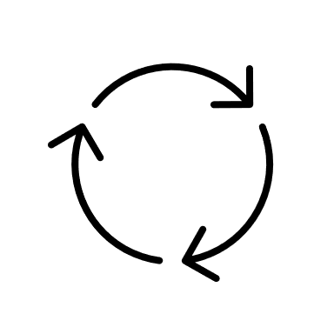3 times
Materials needed:
Virtual Winding Game: https://www.geogebra.org/m/jrvh4e8d
Recording Sheet
Pencil
Author: Bruce Dewey
Math Literacy Initiative
Terri Bucci, Director
Debe Adams, Content Specialist
Bruce Dewey, Senior Intern
Alexander Naples, Marketing Intern

